Diamond SC Cavities LLRF – Initial Control Specifications V1

Introduction
The EPICS Device Server or Server IOC should be in charge of exchanging information between the Perseus Boards and the Graphical User Interface.
Nutaq provides two different ways of accessing and configure the Perseus and FMC Boards through the Linux Host PC installed in the same chassis than the Nutaq boards:
- Command Line Interface (CLI): python script that provides a command shell to configure FMC and Carrier
- EAPI: Interface based on C++ libraries
In this document, the basic commands to access, program and configure the LLRF system will be described based on the CLI interface.
For the complete list of commands and attributes that can be modified through the “CLI” interface, please refer to the “Programmers Reference Guide Command Line Inerface.pdf”:
..\..\..\..\..\..\Nutaq\ADP6\ADP_MicroTCA\documentation\pdf\API\Programmer's Reference Guide Command Line Interface.pdf
For the complete list of functions available in the EAPI, please refer to the “Nutaq MicroTCA BSDK API”
..\..\..\..\..\..\Nutaq\ADP6\ADP_MicroTCA\documentation\pdf\API\microtca_bsdk_api.pdf

LLRF initialization

Connection to Perseus Boards through CLI Interface
To start this Command Line Interface, the user should follow next steps:
- Open a terminal in the Linux Host PC
- Browse to the CLI folder: /opt/Nutaq/ADP6/ADP_MicroTCA/sdk/bin
- Run the CLI script as super user: sudo ./adp_cli.py
- Establish connection with the Perseus Board with the command “connect” and the IP address of the board. Example: connect 192.168.0.101

Initialization of Nutaq boards
As soon as the uTCA Linux CPU is started, the Device Server (DS) or Server IOC controlling the LLRF should start automatically and the initialization process of the Perseus boards should be done. The initialization process consists of:
- Configuration of the internal PLL of the Perseus Board
- Configuration and calibration of the DACs of the MO1000 board of the Perseus System
- Configuration of the ADCs of the MI125 board of the Perseus System
- Configuration of the GPIO bus of the Mestor Breakout Box of Perseus System
- Configuration of the VCXO/PLL of the Loops Front End
Table 1 shows the commands to configure Perseus Board with one MO1000 and one MI125 FMC boards
Initialization commands of Perseus Loops Board | Comments
custom_register_write 4 1  mo1000_powerup 1  mo1000_reset 1  mo1000_init 1  mo1000_setdacparinterpolation 1 1x  mo1000_dodacupdate 1  mo1000_setclockconfig 1 Ext 80000000 80000000 Manual 80000000  mo1000_writeclockconfig 1  mo1000_dodaccalibration 1  mo1000_setdacoutctrl 1 1 Enable  mo1000_setdacoutctrl 1 2 Enable  mo1000_setdacoutctrl 1 3 Enable  mo1000_setdacoutctrl 1 4 Enable  mo1000_setdacoutctrl 1 5 Enable  mo1000_setdacoutctrl 1 6 Enable  mo1000_setdacoutctrl 1 7 Enable  mo1000_setdacoutctrl 1 8 Enable  mo1000_gettemperature 1 temp1c  mi125_powerup 2  mi125_reset 2  mi125_set_clksrc 2 BOTTOMFMC  mi125_get_temperature 2 TEMP1C  custom_register_write 4 0 | Command to reset Asyn FIFO of DACs  Clock source: External and set to 80MHz  Removal of reset of async FIFO of DACs
Table 1.-Initialization commands of Perseus Loops Board
Following tables show the whole available commands to configure the FMC boards of the LLRF: MO1000 FMC Board (DACs board) and MI125 FMC Board (ADCs board)
Command | Argument | Description | Example
mo1000_powerup | - ID of the MO1000 (1 or 2) | Powers up a MO1000 FMC | mo1000_powerup 1
mo1000_reset | - ID of the MO1000 (1 or 2) | Resets a MO1000 to its default non operating condition | mo1000_reset 1
mo1000_init | - ID of the MO1000 (1 or 2) | Initializes a MO1000 to its default operating condition | mo1000_init 1
mo1000_getstatus | - ID of the MO1000 (1 or 2) | Gets MO1000 board status and pattern test errors | mo1000_getstatus 1
mo1000_gettemperature | - ID of the MO1000 (1 or 2)  - Output format | Gets board PCB and DACs temperatures | mo1000_gettemperature 1 temp1c
mo1000_getchannelcalibstatus | - ID of the MO1000 (1 or 2) | Gets MO1000 board calibration status | mo1000_getchannelcalibstatus 1
mo1000_dodaccalibration | - ID of the MO1000 (1 or 2) | Performs a MO1000 calibration | mo1000_dodaccalibration 1
mo1000_setdacoutctrl | - ID of the MO1000 (1 or 2)  - DAC channel ([1,8])  - DAC output state | Controls the DAC output state for the specified channel | mo1000_setdacoutctrl 1 1 enable
mo1000_setclockconfig | - ID of the MO1000 (1 or 2)  - Clock source  - Source clock frequency (if clock source is not 125MHz)  - DAC clock desired frequency  - Master clock mode  - Master clock frequency (if clock mode is manual) | Sets up the clocks of the module | mo1000_setclockconfig 1 125mhz 0 250000000 auto 0
mo1000_writeclockconfig | - ID of the MO1000 (1 or 2) | Writes the module clocks setup prepared with mo1000_setclockconfig | mo1000_writeclockconfig 1
mo1000_getpllconfig | - ID of the MO1000 (1 or 2) | Gets the module PLL parameters prepared with mo1000_setclockconfig | mo1000_getpllconfig 1
Table 2.- MO1000 CLI commands
Command | Argument | Description | Example
mi125_reset | - MI125 target board (1) | Resets and initializes the MI125 (ADC, clock routing, all options...) with default values. | Mi125_reset 1
mi125_powerup | - MI125 target board (1) | Powers up the MI125 board. | mi125_powerup 1
mi125_digital_adccalibration | - MI125 target board (1) | Forces the ADC output digital calibration. | mi125_digital_adccalibration 1
mi125_set_config | - MI125 target board (1)  - Channel group  - ADC output LVDS  - ADC output randomize mode  - ADC output data format | Configures board options. | mi125_set_config 1 16channels termon1750ua randomizeoff twocomplement
mi125_set_clksrc | - MI125 target board (1)  - Clock source (125 MHz,EXT, BOTTOMFMC,FMCCARRIER) | Configures ADC clock source | mi125_set_clksrc 1 125mhz
mi125_checkcore | - MI125 target board (1) | Checks for the MI125 FPGA core presence. | mi125_checkcore 1
mi125_set_testmode | - MI125 target board (1)  - Testmode (TESTMODEOFF, TESTMODE1, TESTMODE2)  - Pattern | Configures the ADC test mode or not. In test mode, the digital interface will continuously send the programmed pattern. | mi125_set_testmode 1 testmode2 0x33CC
mi125_get_temperature | - MI125 target board (1)  - Temperature data output format to use (TEMP1C, TEMP0DOT1C) | Gets the PCB temperature. | mi125_get_temperature 1 temp1c
mi125_get_channelcalibstatus | - MI125 target board (1) | Gets the ADC last digital calibration status. | mi125_get_channelcalibstatus 1
mi125_get_versions | - MI125 target board (1) | Gets the FPGA core and firmware version of the board. | mi125_get_versions 1
mi125_checkadc | - MI125 target board (1)  - ADC id to verify (ADCX, x = 0 to 3) | Runs the ADC check. | mi125_checkadc 1 ADC0
mi125_set_trigout | - MI125 target board (1)  - Trigger output configuration (TRIGOUTON, TRIGOUTOFF) | Configures the MI125 trigger output. | mi125_set_trigout 1 trigoutoff
mi125_get_clkmaster | - MI125 target board (1) | Gets if the module is a clock master. | mi125_get_clkmaster 1
mi125_clockreset | - MI125 target board (1) | Forces an MCM clock reset. | mi125_clockreset 1
Table 3.- MI125 CLI Commands

User-defined custom registers
Besides the general functions developed by Nutaq to configure the hardware of the FMC mezzanines, the Perseus boards have 32 user-defined custom registers that can be used to write/read data into/from FPGA. Each of these registers allows writing/reading words of 32 bits and they have been configured to write/read the settings of the LLRF and also the diagnostic signals displayed in the LLRF GUI.
Table 4 shows the offset address of the user-defined registers that have been used for LLRF adjustments. These offset addresses are the same ones for the Loops Board than for the Diagnostics Board.
User-define register | Offset address | LLRF use
Register 10 | 0x70000040 | LLRF Settings Write
Register 11 | 0x70000044 | LLRF Settings Read-back
Register 12 | 0x70000048 | LLRF Diagnostics
Register 13 | 0x7000004C | GPIO Bus Configuration – write settings
Register 14 | 0x70000050 | Read-back of GPIO Bus Configuration and read-back of slow ADCS of Mestor Breakout Boxes
Register 15 | 0x70000054 | Cavity Type selection: ‘0’ or ‘1’ for Normal conducting cavities, ‘2’ for Super Conducting cavities, ‘3’ for Booster Cavity
Register 31 | 0x70000094 | FPGA version read-back
Table 4.- User-defined custom registers used for Settings and Diagnostics of LLRF
In order to access any of these register, either to write data or to read data, the commands depicted in Table 5 should be used.
Command | Argument | Description | Example
read | - Internal bus address (available addresses are in the 0×60000000–0×7FFFFFFF and 0×85000000–0×8FFFFFFF ranges) | Reads 32 bits of data from an absolute address in the FPGA AXI bus. | read 0x70000010
custom_register_read | - Custom register ID (available IDs are 0-31) | Reads 32 bits of data from a custom register ID in the FPGA AXI bus. | custom_register_read 0
write | - Internal bus address (available addresses are in the 0×60000000–0×7FFFFFFF and 0×85000000–0×8FFFFFFF ranges)  - Data to write | Write 32 bits of data in an absolute address in the FPGA AXI bus. | write 0x70000010 0x6D
custom_register_write | - Custom register ID (available IDs are 0-31)  - Data to write | Write 32 bits of data in a custom register ID in the FPGA AXI bus. | custom_register_write 0 0x6D
Table 5.- Commands to write/read data to/from the communication bus of the Perseus Boards

Configuration of GPIO Bus of and readings of Slow ADCs of Mestor Breakout Boxes
Before starting the operation of the LLRF, the user should configure the GPIO bus of the Mestor Breakout Box. The Mestor Breakout Box has a digital bus of 32 bits. Each of these bits can be configured as inputs or outputs. By default, when the Mestor Breakout Box is switched on, all 32 bits are outputs. For the LLRF application, the 16LSBs should be configured as inputs and the 16MSBs should be configured as outputs.
The commands to do this are sent through user-define custom register 13, whose offset address is 0x7000004C. The 32bits words that will be sent through this register will be split by the FPGA into two parts: the 16MSBs will be used as internal address of the GPIO bus configuration and the 16LSBs will be data to be written or read. Error: Reference source not found describes the internal addresses implemented through user-defined register 13 to configure the GPIO bus.
Data to be sent through register 13 (offset 0x7000004C)
Address  16MSBs | Signal – Data value in 16LSBs | Range | Comment
0 | Reset | Boolean | 1 – Reset, 0 – Reset removed
1 | GPIO Direction Configuration LSBs | [0,65535] | Each bit configures of this data Word configures the direction the LSBs. 1 → Input, 0→ Output
2 | GPIO Direction Configuration MSBs | [0,65535] | Each bit configures of this data Word configures the direction the LSBs. 1 → Input, 0→ Output
3 | Set GPIO Direction | Boolean
4 | Start Synchronization | Boolean
5 | Disable LLRF GPIO Outs and Enable Slave GPIO Outputs | Boolean | When asserted high, the data to be send/receive through the GPIO bus will be equal to the data described in address ‘6’ and ‘7’
6 | Slave GPIO Outputs value LSBS | [0, 65535]
7 | Slave GPIO Outputs value MSBs | [0, 65535]
Table 6.-Internal address to configure GPIO bus through register 13
Table 7 shows the commands that should be used to configure the GPIO bus.
Commands to Configure GPIO Bus both for Loops Perseus Board and Diagnostics Perseus Board
Command | Comment
write 0x7000004C 0x1 | Reset
write 0x7000004C 0x0 | Reset removed
write 0x7000004C 0x1ffff | Direction of 16LSBs of GPIO as inputs
write 0x7000004C 0x20000 | Direction of 16MSBs of GPIO as outputs
write 0x7000004C 0x30001 | Send direction settings of GPIO bus
write 0x7000004C 0x30000
write 0x7000004C 0x40001 | Synchronization of GPIO bus
write 0x7000004C 0x40000
Table 7.- Commands to configure GPIO Bus through custom register 13
Custom register 14 has been used to read the configuration parameters of GPIO bus and also to read the data of the Slow ADCs of the Mestor Breakout Box. In this case, the user should write the internal address of the signal of interest in register 14. Then it should read-back the value of register 14 and the data corresponding to that internal address will be displayed.
Data to be write/read through register 14 – Offset 0x70000050
address | Signal | Range
0 | Reset | Boolean
1 | GPIO Direction Configuration LSBS | [0,65535]
2 | GPIO Direction Configuration MSBS | [0,65535]
3 | Set GPIO Direction | Boolean
4 | Start Synchronization | Boolean
16 | Ready Signal | Boolean
17 | Start Acknowledgment | Boolean
18 | Set GPIO Direction Acknowledgement | Boolean
19 | Data to be sent to GPIO - MSBs | [0, 65535]
20 | Data to be sent to GPIO - LSBs | [0, 65535]
21 | Data read from GPIO - MSBs | [0, 65535]
22 | Data read from GPIO - LSBs | [0, 65535]
23 | ADC Data 0 | [0, 4096]
24 | ADC Data 1 | [0, 4096]
25 | ADC Data 2 | [0, 4096]
26 | ADC Data 3 | [0, 4096]
27 | ADCDataValid3&2&1&0 | Boolean
Table 8.- Internal addresses of register 14 used to read configuration of GPIO bus and slow ADCs of Mestor
Usually, this register will only be used to read the data of the ADCs. The rest of the addresses were implemented just for debugging purposes. For the moment, only the last ADC of Loops Mestor Breakout Box will be used to read the control voltage of the PLL of the CDC-7005-EVM board installed in the Loops Front End.

LLRF Settings

LLRF Write Settings
Once the GPIO bus of Mestor Box has been configured, the user will be able to adjust the settings of the LLRF. All the LLRF settings will be written using the “user custom defined register number 10 – offset 0x70000040”. Every time the user writes a word into this register, the FPGA will decode the information of this word and will modify the corresponding setting.
These registers information is coded in the following way:
- Bits 30 to 17 correspond to the address of the parameter
- Bit 16 unused
- Bits 15 to 0 correspond to the value or data of the parameter
The excel file “Nutaq Registers calculation for Diamond SC Cavities LLRF - PERSEUS - Advanced.xls” summarizes all the settings of the LLRF. The tab “Settings – Loops” of the excel file describes all the settings of the Perseus board. Table 9 shows the information available in this tab
Excel Column of Settings tabs | Description
B | Setting address. To be coded in bits 31 to 17
C | Description of setting
D | Range of this setting to be displayed in GUI of LLRF
E | Desired value of each parameter to be written in the FPGA in mV, degrees or any other physical units
F | Setting value transformed from physical units (mV, degrees, Boolean, etc.) to FPGA units
G | 32 bits word to be sent to FPGA composed of Address (bits 31 to 17) + FPGA data (bits 15 to 0) in decimal format
I | Same information than column ‘G’ in hexadecimal format
Table 9.- Information available in “Settings” tab of Perseus Registers Excel File
In order to change any of the parameters of the FPGA, the values of column “I” have to be written in register 10.
Table 10 shows an example of some parameters of the “Amplitude and Phase Loops” that can be set in the Loops Board
Settings write for Loops Board (register 10 – Chain A – offset 0x70000040; register 20 – Chain B – offset 0x70000068)
B | C | D | E | F | G | I
Address (bits 31 to 17) | Parameter | GUI Range | GUI value | FPGA Value | Add + value (dec) | Add + value (hex)
0 | kp | [0,10] | 0 | 0 | 0 | 0x00000000
1 | ki | [0,32767] | 1 | 1 | 131073 | 0x00020001
2 | Phase Shift Cav | [-180, 360] | 0 | 0 | 262144 | 0x00040000
3 | Phase Shift FwCav | [-180, 360] | 0 | 0 | 393216 | 0x00060000
4 | Phase Shift FwTet1 | [-180, 360] | 0 | 0 | 524288 | 0x00080000
5 | Phase Shift FwTet2 | [-180, 360] | 0 | 0 | 655360 | 0x000A0000
6 | PILimit A | [0,1000] | 800 | 26214 | 812646 | 0x000C6665
7 | # samples to average | [0, 7] enumeration | 0 | 0 | 917504 | 0x000E0000
8 | filter stages | [0, 3] enumeration | 0 | 0 | 1048576 | 0x00100000
9 | Phase Shift FwCircIn | [-180, 360] | 0 | 0 | 1179648 | 0x00120000
10 | Phase Shift Control Signal Tet1 | [-180, 360] | 0 | 0 | 1310720 | 0x00140000
11 | Phase Shift Control Signal Tet2 | [-180, 360] | 0 | 0 | 1441792 | 0x00160000
13 | Gain Tetrode1 | [0.1, 1] | 1.00 | 19898 | 1723834 | 0x001A4DBA
14 | Gain Tetrode2 | [0.1, 1] | 1.00 | 19898 | 1854906 | 0x001C4DBA
15 | Automatic Start-up Enable | Boolean | 0 | 0 | 1966080 | 0x001E0000
16 | Command Start | [0, 7] enumeration | 5 | 5 | 2097157 | 0x00200005
19 | AmpRefIn | [0, 1000] | 100 | 1990 | 2492358 | 0x002607C6
20 | PhRefIn | [-180, 360] | 45 | 8192 | 2629632 | 0x00282000
21 | ampRefMin | [0, 1000] | 100 | 1990 | 2754502 | 0x002A07C6
22 | PhRefMin | [-180, 360] | 45 | 8192 | 2891776 | 0x002C2000
23 | Phase increase rate | [0, 7] enumeration | 7 | 7 | 3014663 | 0x002E0007
24 | Voltage Rate Increase | [0,7] (enumeration) | 7 | 7 | 3145735 | 0x00300007
25 | Gain OL = K · CL | [0.5, 2] | 1.00 | 64 | 3276864 | 0x00320040
Table 10.- Some Parameters of Loops Board

LLRF Settings Read-back
Register 11 is used to read back the settings written in registers 10. In order to read the value of any parameter/setting, the user should write the address of that parameter in register 11, and then read back the value given by the register 11.
The following table shows some examples of the numbers that should be written in register 11 in order to read back the values of the corresponding parameters. The whole table parameters are available in the “Settings – Loops” and “Settings – Diagnostics” of the excel file.
Register 11 | to Read parameters |  | Conversion Function
Address | Parameter | GUI Range | GUI value | FPGA Value | Register Value
0 | kp | [0,10] | 0 | 0 | 0
1 | ki | [0,32767] | 1 | 1 | 1
2 | Phase Shift Cav | [-180, 360] | 0 | 0 | 0
3 | Phase Shift FwCav | [-180, 360] | 0 | 0 | 0
4 | Phase Shift FwTet1 | [-180, 360] | 0 | 0 | 0
5 | Phase Shift FwTet2 | [-180, 360] | 0 | 0 | 0
6 | PILimit A | [0,1000] | 800 | 26214 | 26214
7 | # samples to average | [0, 7] enumeration | 0 | 0 | 0
8 | filter stages | [0, 3] enumeration | 0 | 0 | 0
9 | Phase Shift FwCircIn | [-180, 360] | 0 | 0 | 0
10 | Phase Shift Control Signal Tet1 | [-180, 360] | 0 | 0 | 0
11 | Phase Shift Control Signal Tet2 | [-180, 360] | 0 | 0 | 0
13 | Gain Tetrode1 | [0.1, 1] | 1.00 | 19898 | 19898
14 | Gain Tetrode2 | [0.1, 1] | 1.00 | 19898 | 19898
15 | Automatic Start-up Enable | Boolean | 0 | 0 | 0
16 | Command Start | [0, 7] enumeration | 5 | 5 | 5
19 | AmpRefIn | [0, 1000] | 100 | 1990 | 1990
20 | PhRefIn | [-180, 360] | 45 | 8192 | 8192
21 | ampRefMin | [0, 1000] | 100 | 1990 | 1990
22 | PhRefMin | [-180, 360] | 45 | 8192 | 8192
23 | Phase increase rate | [0, 7] enumeration | 7 | 7 | 7
24 | Voltage Rate Increase | [0,7] (enumeration) | 7 | 7 | 7
25 | Gain OL = K · CL | [0.5, 2] | 1.01 | 64 | 64
32 | FDL Sw Trigger | Boolean | 0 | 0 | 0
Table 11.- Settings read back examples of Loops Board through register 11

LLRF Diagnostics
All the diagnostics signals are read through register 12. In order to read the information of the all the signals corresponding to the same moment, all the diagnostics signals are stored in latches and they are only updated when the word X”0001_0000” (“refresh diagnostics board”) is written in the register 12. The FPGA board detects the rising edge of bit ‘16’ in register 12. So in order to update again this data, the bit ‘16’ of register 12 should be set to ‘0’ and then back to ‘1’.
After sending the “refresh diagnostics word” to register 12, the user should write the address of the diagnostic signals that needs to read.
The following table describes some examples of diagnostics signals of the loops board. The whole tables are available in the tabs “Readings – Loops board” and “Readings – Diagnostics Board”.
Address (16 LSBs) | Address hex | Diagnostics Signal | Register Value | GUI value transformation
0 | 0000 | Icav_loops | 10 | 0.31
1 | 0001 | Qcav_loops | 10 | 0.31
2 | 0002 | Icontrol | 10 | 0.31
3 | 0003 | Qcontrol | 10 | 0.31
4 | 0004 | IControl 1 | 10 | 0.31
5 | 0005 | QControl 1 | 10 | 0.31
6 | 0006 | IControl 2 | 19 | 0.58
7 | 0007 | QControl 2 | 10 | 0.31
8 | 0008 | Ierror | 10 | 0.31
9 | 0009 | Qerror | 10 | 0.31
10 | 000A | IErrorAccum | 10 | 0.31
11 | 000B | QErrorAccum | 10 | 0.31
12 | 000C | Iref | 10 | 0.31
13 | 000D | Qref | 10 | 0.31
14 | 000E | IFwCav_loops | 11 | 0.34
15 | 000F | QFwCav_loops | 12 | 0.37
16 | 0010 | IFwTet1_loops | 13 | 0.40
17 | 0011 | QFwTet1_loops | 14 | 0.43
18 | 0012 | IFwTet2_loops | 15 | 0.46
19 | 0013 | QFwTet2_loops | 16 | 0.49
20 | 0014 | IFwCircIn_loops | 17 | 0.52
21 | 0015 | QFwCircIn_loops | 18 | 0.55
22 | 0016 | IMO | 19 | 0.58
23 | 0017 | QMO | 20 | 0.61
24 | 0018 | ISpare1 | 21 | 0.64
25 | 0019 | QSpare1 | 22 | 0.67
26 | 001A | ISpare2 | 23 | 0.70
27 | 001B | QSpare2 | 24 | 0.73
28 | 001C | IMuxCav | 25 | 0.76
29 | 001D | QMuxCav | 26 | 0.79
30 | 001E | IMuxFwCav | 27 | 0.82
31 | 001F | QMuxFwCav | 28 | 0.85
32 | 0020 | IMuxFwTet1 | 29 | 0.89
33 | 0021 | QMuxFwTet1 | 30 | 0.92
34 | 0022 | IMuxFwTet2 | 31 | 0.95
35 | 0023 | QMuxFwTet2 | 32 | 0.98
36 | 0024 | IMuxFwCircIn | 33 | 1.01
37 | 0025 | QMuxFwCircIn | 34 | 1.04
38 | 0026 | AmpCav | 50 | 1.53
39 | 0027 | AmpFw | 50 | 1.53
40 | 0028 | AngCavFw | 50 | 0.27
41 | 0029 | AngCavL | 50 | 0.27
42 | 002A | AngFwL | 50 | 0.27
43 | 002B | Vaccum1 | 1 | ON
44 | 002C | Vaccum2 | 1 | ON
45 | 002D | Icontrol_SlowPI | 34 | 1.04
46 | 002E | Qcontrol_SlowPI | 34 | 1.04
47 | 002F | Icontrol_FastPI | 34 | 1.04
48 | 0030 | Qcontrol_FastPI | 34 | 1.04
49 | 0031
50 | 0032 | VCXO_Powered | 0 | 0
51 | 0033 | VCXO_Ref | 0 | 0
52 | 0034 | VCXO_Locked | 0 | 0
53 | 0035 | VCXO Cable disconnected | 0 | 0
Table 12.- Examples of how to read diagnostics signals through register 12 of Loops Board

VCXO programming
The external clock of the Perseus boards is provided by a PLL board from Texas Instruments (CDC7005-EVM). This board has an 80MHz VCXO that should be locked either with the Master Oscillator Signal (MO) or with a signal whose frequency is locked with the Master Oscillator.
The CDC7005-EVM board provides up to 5 outputs, whose frequency can be programmed through the VCXO GUI. This VCXO GUI will also be used to specify the ratio between the frequency of the VCXO and the frequency of the reference signal so the phase frequency detector (PFD) of the Texas Instruments board can lock the outputs of the VCXO with the Reference Input.
As shown in Figure 1, the output of the VCXO is sent to a fan-out to provide up to 5 outputs. Each fan-out output can be divided by a power of two up to 16. The parameters: “Mux0 Divider”, “Mux1 Divider”, “Mux2 Divider”, “Mux3 Divider”, “Mux4 Divider” set the value of these dividers. The “MuxSel” parameter is used to select which VCXO fan-out output will be sent to the PFD loop.
The inputs of the PFD are the reference input divided by “Reference Divider M” and one output of the VCXO fan-out divided by “VCXO Reference Divider N”, as depicted in Figure 1:
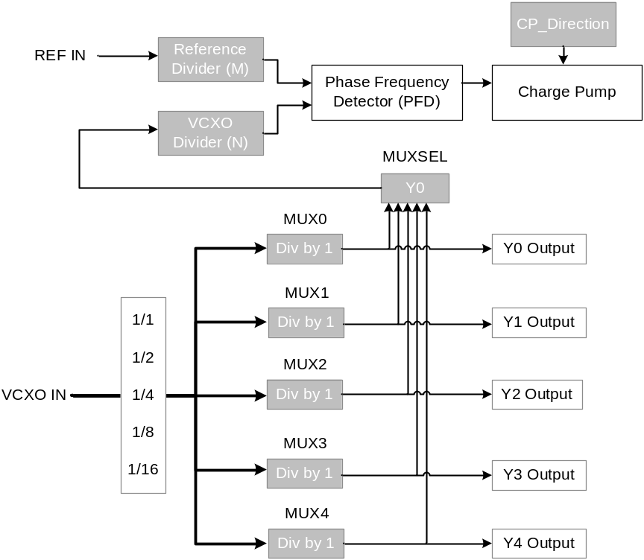
Figure 1.- Parameters of PLL Board.
The frequency of the two inputs of the PFD should be the same, and thus, the following formula should be maintained in order to be able to lock the PLL:
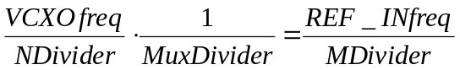
Equation 1.- Relation between PLL parameters and RF signals Frequency (Reference and VCXO)
The configuration parameters of the VCXO are also sent through custom register 10. These parameters should be sent just after initialization of the FMC Boards.
Parameter | value | Command to be sent through CLI to configure VCXO
M Divider (ref) | 10 | write 0x70000040 | 0x03E80009
N divider (VCXO) | 8 | write 0x70000040 | 0x03EA0007
MuxSel | 0 | write 0x70000040 | 0x03EC0000
Mux0 Divider | 0 | write 0x70000040 | 0x03EE0000
Mux1 Divider | 2 | write 0x70000040 | 0x03F00002
Mux2 Divider | 0 | write 0x70000040 | 0x03F20000
Mux3 Divider | 0 | write 0x70000040 | 0x03F40000
Mux4 Divider | 0 | write 0x70000040 | 0x03F60000
Send Word | 0 | write 0x70000040 | 0x03F80000
CP_Dir | 1 | write 0x70000040 | 0x03FA0001
VCXO Output inversion | 0 | write 0x70000040 | 0x03FC0000
Send Word | 1 | write 0x70000040 | 0x03F80001
Table 13.- VXO parameters to be sent through custom register 10

FPGA program
The steps to run the CLI in the Linux Host PC and reprogram the FPGA are the following ones:
- Open a terminal in the Linux Host PC
- Browse to the CLI folder: /opt/Nutaq/ADP6/ADP_MicroTCA/sdk/bin
- Run the CLI script as super user: sudo ./adp_cli.py
- Establish connection with the Perseus Board with the command “connect” and the IP address of the board. Example: connect 192.168.0.101
- Reprogram the FPGA with the “fpgaflash” command. The arguments for this command are: Index (1 or 2), bit stream file path to flash and comment (optional) (this action may take several minutes): fpgaflash 1 “C:\download.bit” “This is my comment”
- Reboot the FPGA so the new program is loaded from the flash: reboot
- Exit the CLI script and open it again to establish connection with the Perseus boards.

FPGA version
One way to check if the FPGA has been well programmed is looking at the FPGA version code, which will be available in the “LLRF GUI” in the tab “FPGA version”.
This version code is composed of 10 digits, the first 4 correspond to the year of the code version, the following 2 correspond to the month, the following 2 to the day and the last 2 will be version number corresponding to that day.

RAM Initialization for Fast Data Logger
To initialize the RAM of the Fast Data Logger and send the stored data from the Perseus to the hosts, the commands shown in Error: Reference source not found should be sent. The user should take into account that there are two stages for a “Fast Data Logger” Acquisition:
- Initialization of FDL memory buffer BEFORE Interlock Trigger or Acquisition on demand
- Data retrieval AFTER Interlock Trigger or Acquisition request
The default values shown in Table 14 are configured to retrieve 10ms of data after the interlock.
Commands to be sent to initialize RAM of Fast Data Logger BEFORE INTERLOCK
ram_init
recplay_record 25600000 1
Commands to be sent to initialize RAM of Fast Data Logger AFTER INTERLOCK
recplay_record_check_transfer_done 200
ram_get ../../bin/record.bin 0 25600000 1024 200
Table 14.- Commands for Fast Data Logger transfer from Perseus to Host

LLRF GUI
The expert LLRF GUI will be divided in five main parts, as depicted in Figure 2
- Start Menu
- Main Parameters
- Main Diagnostics
- Fast Interlocks: Parameters and Diagnostics
- Fast Data Logger Menu
All the parameters are defined for RF Chain A and RF Chain B and their behaviour is identical, although they can be set independently
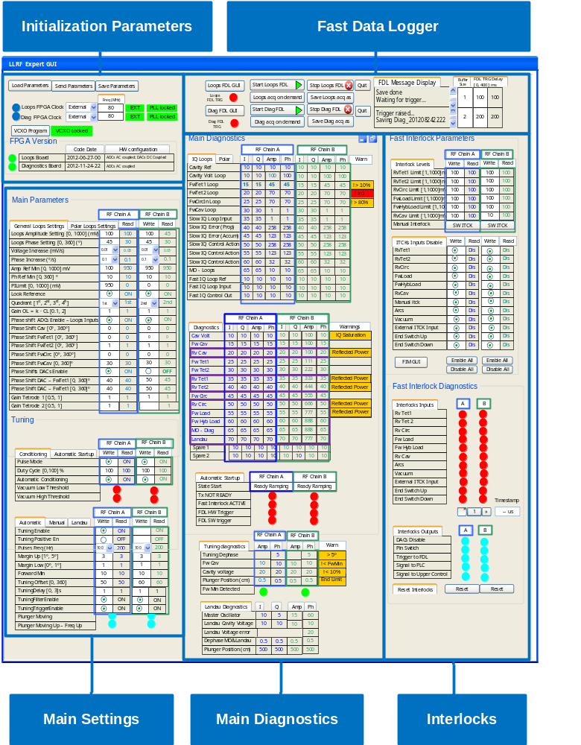
Figure 2.- Diamond SC Cavities LLRF Expert GUI

Note that the path of the Command Line Interface (CLI) python script may vary depending on the version of the Perseus Drivers.
For more information on this board refer to texas instruments webpage: www.ti.com
Note that the path of the Command Line Interface (CLI) python script may vary depending on the version of the Perseus Drivers.

